Experienced Cyclist

Taeho, Kathleen, and Cecilia

# Shannon Ramirez

28, Arizona  
Nature Photographer (Freelance), $50K annual

## Relevant demographic or personal background details

Mixed hispanic American woman. Divorced with no kids. Local from Arizona. Grew up on the road with her parents. BA in Environmental sciences in the US but spent a year apprenticing in France.

## Personality

Adventurous, independent, curious, Self-motivated, stubborn, Self-centered sometimes.

## Health or medical factors

Generally fairly fit and healthy. Prides herself on a healthy lifestyle.

## Eco-consciousness

Strong investment in environmental conservation. Promotes being environmentally conscious. Helps lead a “Green community” group in Arizona.

## Interest / experience / history with cycling / owning a bike

Owns several good-quality bikes. Has been biking since childhood (with her family) but became interested in professional cycling in France in her 20s. Runs triathlons between big projects. Hasn’t won one yet, but she is determined.

## Forms of transportation used or in use

Travels a lot for work. Hikes and cycles for work but also uses local transportation at international destinations. Borrows her sister’s van when she is home.

## Have they bought a bike before?

Has several good-quality bikes, some for mountaineering/off-roading, some for more general use.

## Comfort level with shopping online

Fairly comfortable with modern technology so has a fair bit of experience with shopping online.

## Who are they buying for?

Herself; Shannon is replacing a bike that got damaged on her most recent job photographing the grand canyon.

## User stories

* As an experienced cyclist, I want a high quality mountain bike so that I can ride on steeper inclines and be safe when putting a brake in muddy grounds.
* As someone who owns multiple bikes, I want access to lots of specs so that I can compare to the bikes that I already have or have had.
* As someone who goes off roading, I want the option to have a warranty or access to servicing.
* As someone who has used many bikes, I want the option to explore brands that I haven’t used before
* As someone who likes to carry my camera gear with me, I need to know what braze-ons (attachment points) a bike has for racks and the like.
* As an off-road rider, I want a bike with a very wide range of gears so that I can climb steep grades but also zoom on the straightaways.
* As someone who bikes long distances, I want to make sure the bike is durable even in harsh environments.
* As someone versed in cycling culture, I would love to know which bikes, if any, are endorsed by reputable cycling magazines or famous cyclists.
* ​​As someone who got injured from riding a bike before, I want to buy a robust bike and have access to the safety information about the bikes.
* As someone living in Arizona, I want to know if my bike will be delivered directly to my home, or if I will have to travel to a pickup location.
* As someone on a lower salary, I would love to be able to filter out bikes that are outside of my price range
* As someone who is eco-conscious, I want my bike compartments to be made sustainably
* As someone who will be taking my bike internationally, I want to know if it can be easily compacted for shipping/travel
* As someone who will be taking supplies with me on my trips, I want to know the weight limit of the bike
* As someone who is curious and loves cycling, I want to know the newest bikes that can be offered.
* As someone who is on a budget, I want to be able to easily identify bikes that are on sale or discount.
* As someone who is health conscious I want to know if any bikes are recommended by health/fitness experts.
* As a budget-conscious but experienced rider, I want to know if I can afford an aluminum frame because I much prefer them to steel. I’m not likely to buy a steel bike. Too heavy.
* As someone who enjoys online shopping, I want to see a detailed photo of a bike without visiting a store. Close-up shots of the gears and steering would be appreciated.
* As someone who owns many nice bikes and is also eco-conscious, I would love for the store to have a buy-back policy for used bikes.
* As someone who has specific needs and is knowledgeable about bikes, I want to know if and how I can customize a bike to my needs.
* As someone who is health conscious, I want to know if I can also buy an odometer that tells me how far I have cycled.
* As someone who bikes in harsher environments, I want to know if I can get a durable helmet in addition to my bike. Can I compare helmets?
* As someone who will be using my bike a lot, I would like to be able to buy an air pump with my bike.
* As someone who travels on bumpy grounds frequently, I want to make sure the tires don’t air out quickly or get punctured. Can I buy replacement tires if my tires pop?
* As someone who may bike in high altitudes or cold environments, can I buy winter tires for safe cycling in the snow. Are they easily switched out?

Casual Rider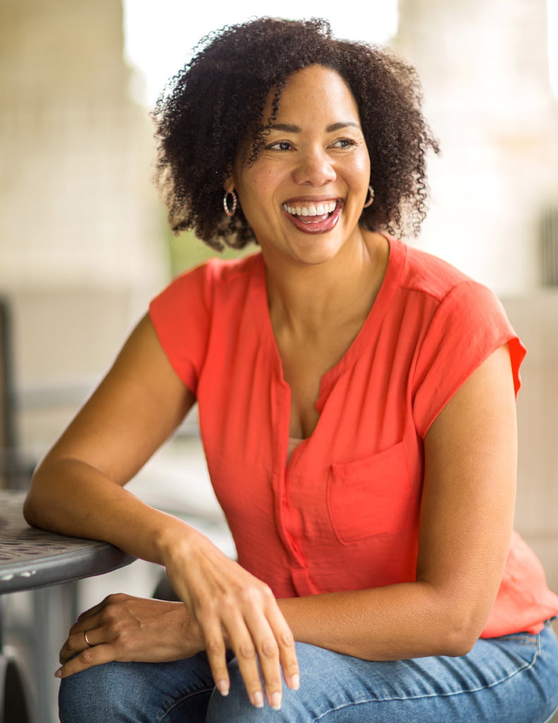

*Seri Park and Meg Barry*

# Ava Windsor

43, Clayton, (Central west end)

Environmental Engineer, $70K annual

## Relevant demographic or personal background details

married with a school-aged kid, moved from California because of job transfer. A former athlete who enjoys basketball.

## Personality

enjoys nature, uses cycling as an escape, extroverted, has many worries, a lot of stress from her job

## Health or medical factors

physically healthy but has a history of mental illness - depression -> uses cycling as a method of recovery

## Eco-consciousness

is eco-conscious, but biking isn’t plausible, drives electrical car to home

## Interest / experience / history with cycling / owning a bike

Sports(Basketball and Baseball), rode a bike as a kid, doctor suggest to get back to it because of depression, had an old bike she’s been using needs an upgrade

## Forms of transportation used or in use

electrical car

## Have they bought a bike before?

has an old bike

## Comfort level with shopping online

very comfortable, has lots of experience online shopping - Amazon lover

## Who are they buying for?

herself

## User stories

* As a <type of user>, I want <some goal> so that <some reason>.
* As a casual rider I want a bike that is easy to use so that I don’t have to put in a lot of maintenance on it.
* The joy of riding is in seeing the beauty around me. I want to find a bike that puts me upright where I can see the world, not hunched over the handlebars staring at my own feet pedaling.
* I’m a bit nervous about being judged by the hard-core riders. I want a bike that doesn’t make me look like a newb, or a poser.
* As a person who rides a bike for the mental health, I want a bike that can be ridden for a long time so that I can recover from mental health
* As a person living in Missouri, I want a bike suitable for numerous weather events so that I can ride a bike regardless of the time of a year
* As a person living in Missouri, I want a bike that could be easily ridden on the rough/uneven ground so that I can enjoy riding a bike without any difficulty
* As an online shopper, she wants to use an online shopping website that makes her want to buy a bike so that she doesn’t have to leave her comfort home
* As a member of upper middle class, I want a bike that is high quality but also not too expensive so that I am getting a good value
* As a person who is extroverted and enjoys a nature, I want a bike that is professional so that I can join a cycling club/community in the future (long term)
* As an eco-conscious person, i want a bike that is reliable so that it can replace driving as much as possible and can use it for a long time
* As a person who is not aware of every detail of the bike components, I want a bike that is already set up / everything needed is included so that I do not have to spend a lot of time looking for every detail of each component
* As a mother I want a bike that is safe to ensure my well being.

Newbie riding for health

Brian L., Chelsea Y., and Yina L.

# Harold Kohls

57, Florida, Suburbs

Senior VP at Kohls (Closing in on retirement), $450,000

## Relevant demographic or personal background details

3 Grown children, divorced because wife began using Amazon, recently downloaded Christian Mingle and Farmer’s Only.

## Personality

Stubborn, Irritable, type of person to slam keyboard when the internet won’t work.

## Health or medical factors

Got a warning from his doctor that he needs to work out because of his diabetes.

## Eco-consciousness

“Climate change is a hoax.” Actively listens to Alex Jones.

## Interest / experience / history with cycling / owning a bike

Has ridden a trike as a tyke.

## Forms of transportation used or in use

Two cars 1 minivan and 1 black company mercedes.

## Have they bought a bike before?

Not in the last 20 years.

## Comfort level with shopping online

Hates it. Blames it for ruining Kohls.

## Who are they buying for?

Himself.

## User stories

* As a person who is rolling in money, I want a selection of the best bikes around so that I can pick the one I like the most.
* As someone who doesn’t know much about bikes, I want to know others’ opinions on the bike so that I can make a good judgment about which one to buy without doing copious amounts of research.
* As someone who is a bit disgruntled about the process of buying a bike, I want to easily know which bikes are most suited to my purpose so that I don’t have to do copious research on every bike I come across.
* As someone who hasn’t touched a bike in decades, I don’t know any of the fancy bike brands or types. I want to just get this shopping done so that I can get back to Christian Mingle.
* As an impatient, irritable person, I want to know EXACTLY what sorts of is on my bike so that I don’t have to look up more information and spend more time on the internet. If I wanted a lecture I would’ve graduated from college.
* As an impatient, irritable person, I want to be able to navigate easily to what I need to find so that I do not get lost in a web of pages of things I don’t want and rage quit and buy another keyboard.
* As someone who hates online shopping (it ruined Kohl’s), I want to be able to quickly find the bike I want with as few clicks as possible so that I don’t lose it trying to navigate all these pages and buttons.
* As someone who doesn’t like technology, I want everything to be labeled clearly so that I know exactly where I am going in the shopping process and what information to input.
* As a person slightly on the older and unhealthier side (and living alone), I want to know how safe and heavy it is so that I know if I can carry it myself when I need to transport it.
* As a fairly unhealthy and impatient person, I want to know if my bike will come with all the parts so that I don’t have to strain my bad back and bum knee trying to build it myself.
* As someone who is a bit disgruntled about the process of buying a bike, I should get a trial period to see if the bike is good for me. Free returns and shipping are a must if I find it is not suitable so that I’m not wasting my money on trash.
* As someone who knows very little about bikes, I want to know how I can get my bike serviced so that I know who to call if anything breaks or doesn’t work. Also, I don’t want to do any manual labor besides biking itself which I don’t really want to do but my doctor insists if I want to keep both of my feet.
* I’ve heard of these things called recumbent bikes. They look more comfortable. Would they be a good choice for me?
* My useless grandson told me single speed bikes require less maintenance. Would these be a good fit?
* Does rolex make bicycles? If so, where might I buy one?

Commuter

Anais and Brian C.

# John Johnson

27, Seattle, Washington (Urban)

Microsoft SWE, $200,000

## Relevant demographic or personal background details

* Graduated from Grad School,
* happily married
* wife pregnant with first child
* currently going through quarter life crisis

## Personality

Open Minded, Energetic, and Conscientious

## Health or medical factors

Physically healthy, but occasionally has minor back pain from sitting at a desk for too long.

## Eco-consciousness

Very, taking up biking in order to be more eco friendly.

Interest / experience / history with cycling / owning a bike: has biked here and there, never got too into biking as a hobby though.

## Forms of transportation used or in use

Have commuted through walking, metro, and driving his audi a4.

## Have they bought a bike before?

Yes, he bought a bike in college, but has no other experience with purchasing a bike.

## Comfort level with shopping online

Decently comfortable shopping online, nervous about buying a bike without test riding it. Looking for a bike that prioritizes durability, comfortability, and efficiency, since he’ll commute to work with it.

## Who are they buying for?

Himself (to commute to work)

## User stories

* As a <type of user>, I want <some goal> so that <some reason>.
* As a newer/less familiar biker user, I want an informative shopping site so that I know what type of bike works for me.
* As a commuter in a rainy location, I want a bike that can handle bad weather. I don’t want a stripe of mud up my backside.
* As someone with back pain, I want to be able to find the right size and style of bike so that I don’t injure my back further.
* As a husband and expecting father, I want to be able to see safety ratings and specs so that I can feel safe for my family.
* As a commuter, I want a durable bike so that I can commute to work with it daily.
* As someone familiar with Seattle’s hills, I want a bike that’s not going to kill me trying to pedal up a hill. I think I’ve heard of e-bikes that have a pedal-assist motor?
* As someone who works in the tech industry, I want a bike with cool features and technology so that I can fit in with my coworkers.
* As a commuter, I want to purchase an efficient bike so that I can commute to work without wasting too much energy.
* As a software engineer, I want a site that provides technical specs of each bike so that I can compare and contrast.
* As an experienced shopper, I want a detailed and thorough site with reliable reviews so that I can feel comfortable purchasing a bike without riding it.
* As a husband, I want a versatile or gender neutral bike so that my wife can ride it too.
* As someone with back pain, I want a bike with ergonomic designs so that I can protect my health.
* As a person concerned with being eco-friendly, I want a bike from a company with a conscious effort to have a transparent and green production
* As a person that is going through a quarter life crisis, I want a bike that is cool enough so that I wouldn’t look like a boring dad.
* As a person with back pain and health issues, I want a bike that is versatile enough for me to bike in difficult terrain if I happen to pick up biking as a hobby.

Parent / Child

Shiyeon and Jeff

# Bob (Father) / Steven (Son)

42 / 8, Clayton, MO

Doctor / Kid, High middle-income

## Relevant demographic or personal background details

White American parent and child. It’s Steven’s 8th birthday and Bob is looking for something to gift his son. Bob was athletic when he was in his teen years and hoping to find something to keep Steven active.

## Personality

Bob is hyper-focused, hard-working, and understanding. Steven is wild, outgoing, and cheerful.

## Health or medical factors

Luckily Bob and Steven don’t have any medical factors that would limit their athletic abilities. However, Steven happens to have a pollen allergy that becomes severe during spring/ summer.

## Eco-consciousness

Bob and his wife try to be as eco-conscious as they can be in day to day life. They practice recycling regularly and try to teach Steven about the importance of being environment-friendly.

## Interest / experience / history with cycling / owning a bike

Bob owned a bike as a child and used it to bike to his friends’ houses, to the ice cream shop, and to school. Steven has never rode a bike before, but thinks it would be fun to ride to his friends’ houses as well.

## Forms of transportation used or in use

Bob drives his son to school in a sedan and the family minivan. Occasionally, Steven takes the bus.

## Have they bought a bike before?

Bob purchased a bike with his dad when they were of a similar age, and he wants to give Steven the same experience he had. However, he has not purchased a bike since then.

## Comfort level with shopping online

Bob and his wife are Amazon Prime members and frequently purchase items they need online. In terms of larger purchases, they have purchased items such as furniture from Wayfair and buy all of their technology (laptops/TVs/phones/etc.) online. This will be their first purchase of a bike online, as they usually like to try it out in a store.

## Who are they buying for?

Bob is buying for his son, Steve. Might be interested in buying one for himself (??)

## User stories

In this flow, Bob goes to the website in question (used REI in this case) and starts on the Bikes page.

* As a first time bike buyer, I want help knowing which type of bikes are available so that I can make an informed purchase.
* As a parent purchasing a bike for my child, I want to know which type of bike is best for the environment that my child will be riding in.
* As a first time bike buyer, I want to know the most reputable brand so that my child is safe.
* As a high-middle income family, we want to purchase a bike for the right price.
* As a parent purchasing a bike for my child, I want to sort through different customization options to find the right bikes.
* As a first time bike buyer, I want to read reviews of the bike(s) I am interested in to see if it is a reliable bike.
* As a first time bike buyer, I want to be able to compare a bike I am interested in to other bikes on the website in order to determine the best fit for my child.
* As a parent purchasing a bike for my child, I want to see all of the customizations I can make on the bike I am interested in so I can choose customizations that my child would like.
* As a parent purchasing a bike for my child, I want to see what other bike accessories I should get with the bike so my child can be safe.
* As a first time bike buyer, I want to see if there are other bikes for adults that are similar to the bike I am purchasing for my child.
* As a parent purchasing for my child, I would like to search for bikes that reference certain characters that are popular so I can buy a bike that my child would like.
* As a nostalgic dad, I wonder if they still make that Schwinn Stingray with the banana seat like I had as a kid.